**2. Plan the UI Layout**

**a. Dashboard Overview:**

* Display at-a-glance information like:
  + Progress bars for course completion.
  + Scorecards for strengths and weaknesses.
  + Upcoming tasks or goals.

**b. Insights & Analysis:**

* Use interactive visualizations:
  + Line graphs for progress over time.
  + Pie charts for strengths and weaknesses.
  + Heatmaps to show engagement levels.
* Include expandable sections for detailed analysis.

**c. Recommendations Panel:**

* Highlight AI-recommended resources:
  + Suggested videos, articles, or exercises.
  + Include tags for difficulty, topic, or estimated time.

**d. Learning Path Viewer:**

* Use timelines or flowcharts to illustrate the personalized learning journey.
* Allow students to click on milestones for more details.

**e. Feedback Section:**

* Provide AI-generated suggestions in a concise, friendly format.
* Use icons or emojis for quick comprehension (e.g., thumbs up for strengths).

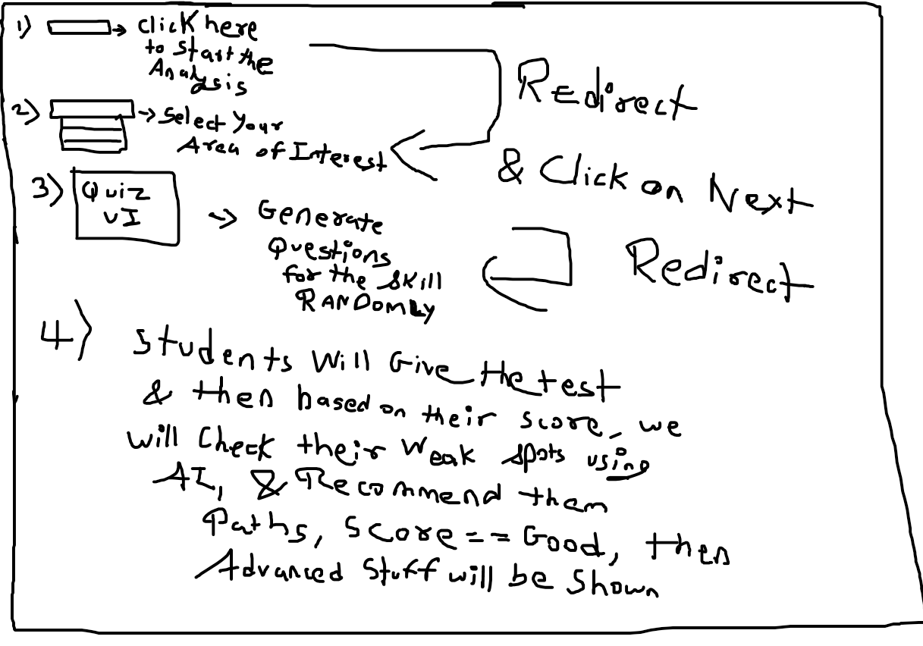

A basic design for AI Analysis

1. on the homepage for the AI ANALYSIS
2. there's gonna be a button, on which when i click,
3. it will open a drop down list to select the student's area of interest, There will be 5 areas of interest at the start, can add more later.
4. after that, suppose i select DBMS, then a quiz is to be generated, for quiz generator, i have the UI, but for the questions,
   1. i might ask u generate 50 questions, and give 10 randomly
   2. might use an MCQ website for it
5. after the questions have been given, the candidate is to take the test
6. max alloted time will be 20 seconds to answer the question
7. next we can analyse the candidate's strength, suppose he understands fundamentals, we can ask him to focus more on coding the statements, if hes weak at fundamentals but knows the syntax, we can suggest him theoretical resources
8. if hes weak at both, we can suggest him both
9. we can ask 5 fundamental and 5 coding ones

**1. Homepage with Dropdown**

* **Button:** Clicking the button triggers a dropdown list of areas of interest (e.g., DBMS, Data Structures, OOP, etc.).
* **Dynamic List:** Keep the list scalable so you can add more areas later. Use a data-driven approach to populate the list dynamically.
* **Example:**
  + Dropdown options: DBMS, Data Structures, OOP, Networking, and Algorithms.

**Implementation Suggestion:**  
Use a dropdown menu with event listeners to capture the selected area and pass it to the next phase.

**2. Quiz Generation**

* **Option (i): AI-Generated Questions:** You can use a script to generate questions (I can help you create them or integrate with an AI API).
* **Option (ii): MCQ Website Integration:** Embed or fetch questions from trusted MCQ sources.
* **Question Randomization:** Use an algorithm to shuffle and pick 10 random questions from a pool of 50.

**Quiz Format:**

* **5 Fundamental Questions:** Focus on definitions, concepts, and theoretical knowledge.
* **5 Coding Questions:** Problem-solving, SQL queries, or code snippets.

**UI Suggestion:**  
Display the quiz with:

* Question at the top.
* Four options below.
* A timer (20 seconds) displayed prominently.

**3. Candidate Test Flow**

* The user takes the quiz.
* After each question:
  + Record the response.
  + Highlight correct/incorrect answers at the end.

**Data to Capture:**

* Number of correct answers in:
  + **Fundamentals.**
  + **Coding.**

**4. Analysis and Feedback**

* **Strength Evaluation:** Based on quiz results:
  + **Strong in Fundamentals:** Recommend advanced coding exercises or projects.
  + **Weak in Fundamentals but Strong in Syntax:** Suggest resources like tutorials or textbooks on basics.
  + **Weak in Both:** Recommend a balanced mix of theoretical and coding resources.

**UI Suggestion for Feedback:**

* Use visual aids:
  + Bar graphs to show performance in fundamentals vs. coding.
  + Text-based recommendations for resources with clickable links.

**5. Scalable Design**

* **Resource Suggestions:** Create a database or JSON file with categorized resources.
* **Modularity:** Design the quiz generator, analysis engine, and feedback as independent modules for future scalability.

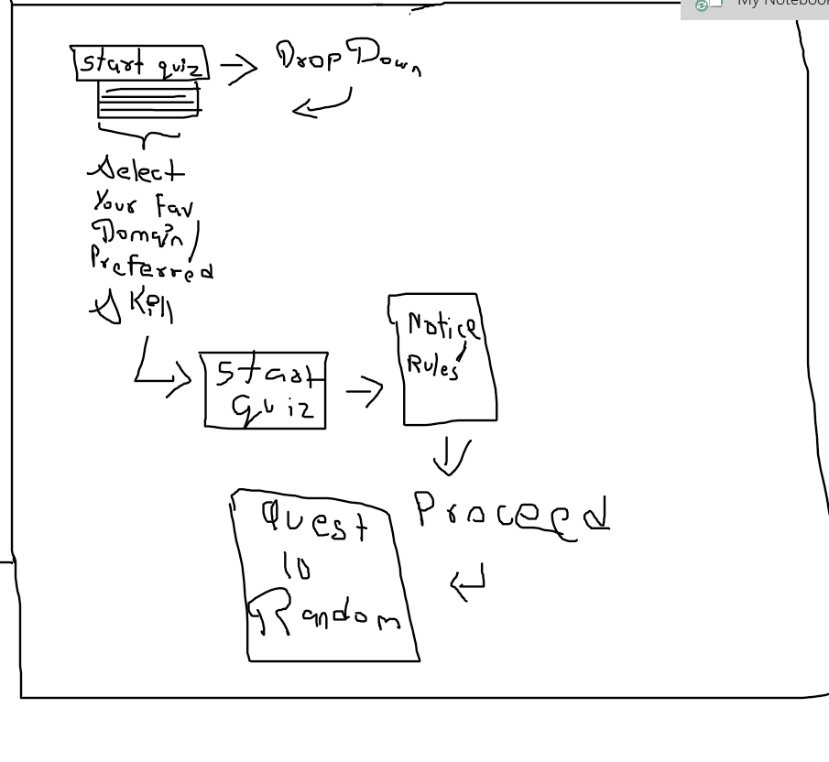Quiz app layout

**1. Visual Progress Indicators**

* **Progress Bars**: Use horizontal or circular progress bars to display completion percentages.
* **Steps Tracker**: Represent milestones or steps with a visual indicator, e.g., a timeline or a stepper.

**Tech to Use**: HTML5 <progress> element, CSS animations, or libraries like Chart.js for graphs.

**2. Task Checklist**

* Add a to-do list where tasks can be marked as complete.
* Sync it **3. Daily/Weekly Goals**
* Let users set goals and track how much they've achieved daily or weekly.
* Include reminders or notifications for incomplete goals.
* **Tech to Use**: JavaScript for setting dates, and localStorage or Firebase for saving progress.

**4. Analytics and Stats**

* Show:
* Time spent on each task.
* Tasks completed this week/month.
* Trends over time (e.g., improving or declining).
* **Tech to Use**: Use **Chart.js** or D3.js for dynamic charts.

**5. Gamification**

* Add badges or rewards for milestones (e.g., 50%, 100% progress).
* Implement a streak tracker for consecutive days of activity.

**6. Progress History**

* Keep a log of all past activities to show how the user has improved over time.
* Display a calendar view of task completion.
* **Tech to Use**: Use libraries like FullCalendar.js for date tracking.

**7. Responsive and Interactive Design**

* Ensure the tracker looks great on all devices.
* Use hover effects or animations to make interactions engaging.

**8. Integration with External Tools**

* Sync with Google Calendar, Trello, or Notion.
* Export progress reports as PDFs or CSV files.
* with the progress bar to update the completion percentage.

**a. Task-Based Tracking**

* Create a **To-Do List** system where users can:
  + Add tasks.
  + Check off completed tasks.
  + View completion percentages.

#### ****b. Habit Tracking****

* Use streak-based tracking (e.g., track how many days in a row tasks are completed).
* Example: "You've studied for 7 days straight!"

**c. Goal Progress**

* Set specific goals (e.g., 10,000 steps/day).
* Show progress with percentage bars or milestones.

**d. Visual Dashboards**

* Include charts, graphs, or heatmaps to give users a clear snapshot of progress.
* Example: A heatmap showing productivity levels over a week.

**e. Gamification**

* Introduce badges, rewards, or challenges for completing milestones.
* Example: "Earn 10 points for every completed task!"

